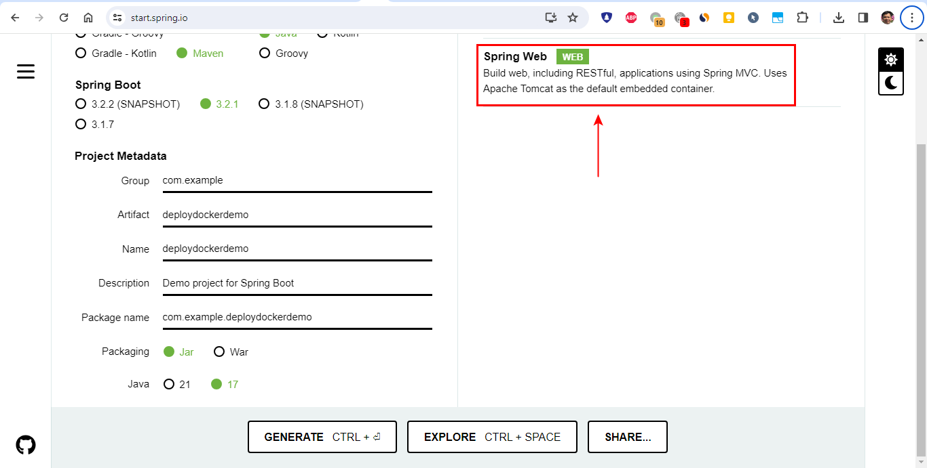

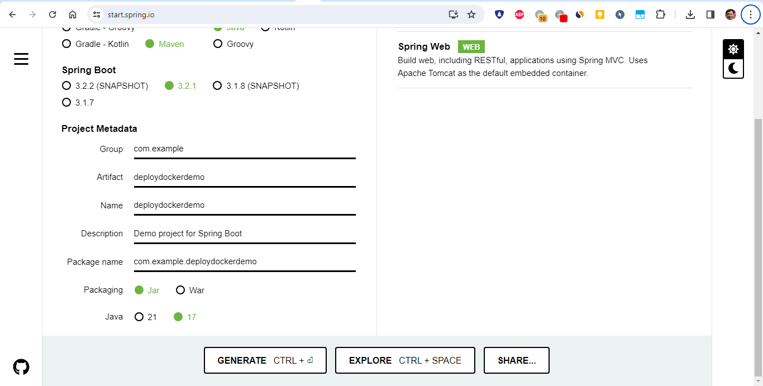

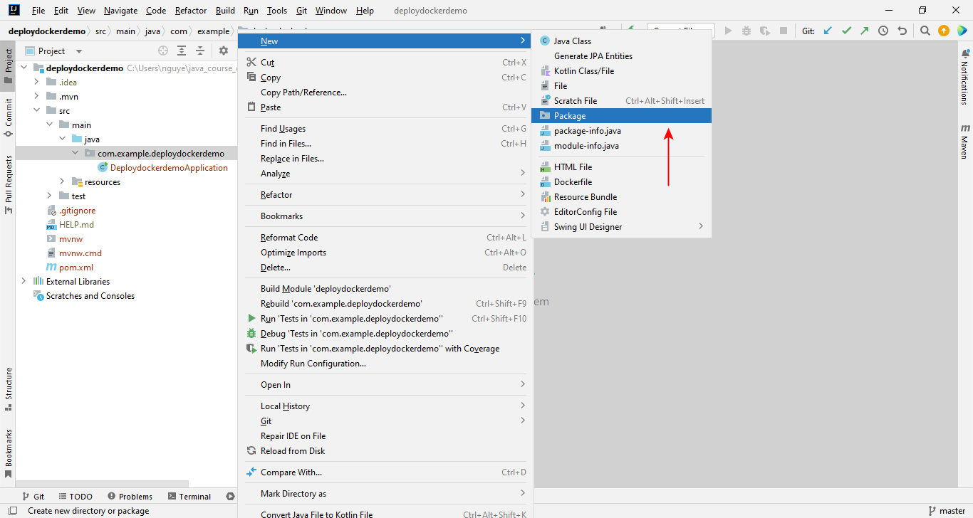

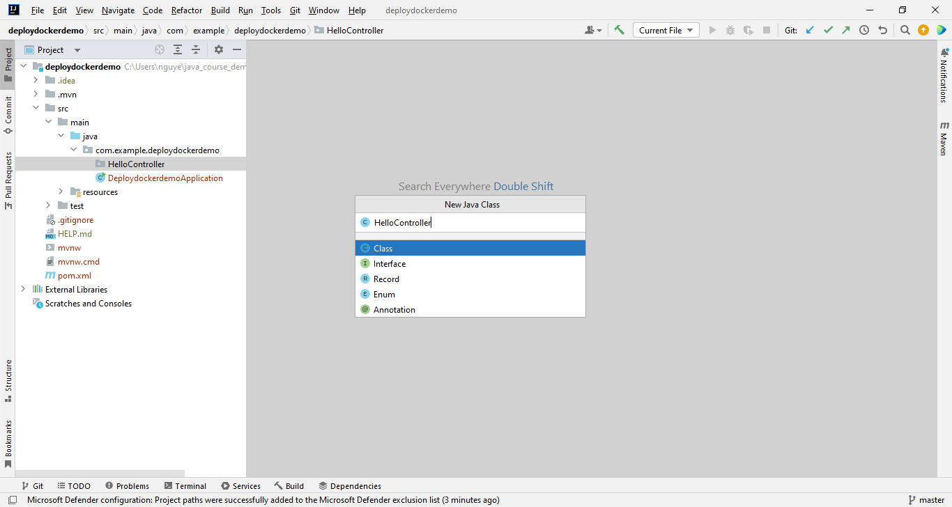

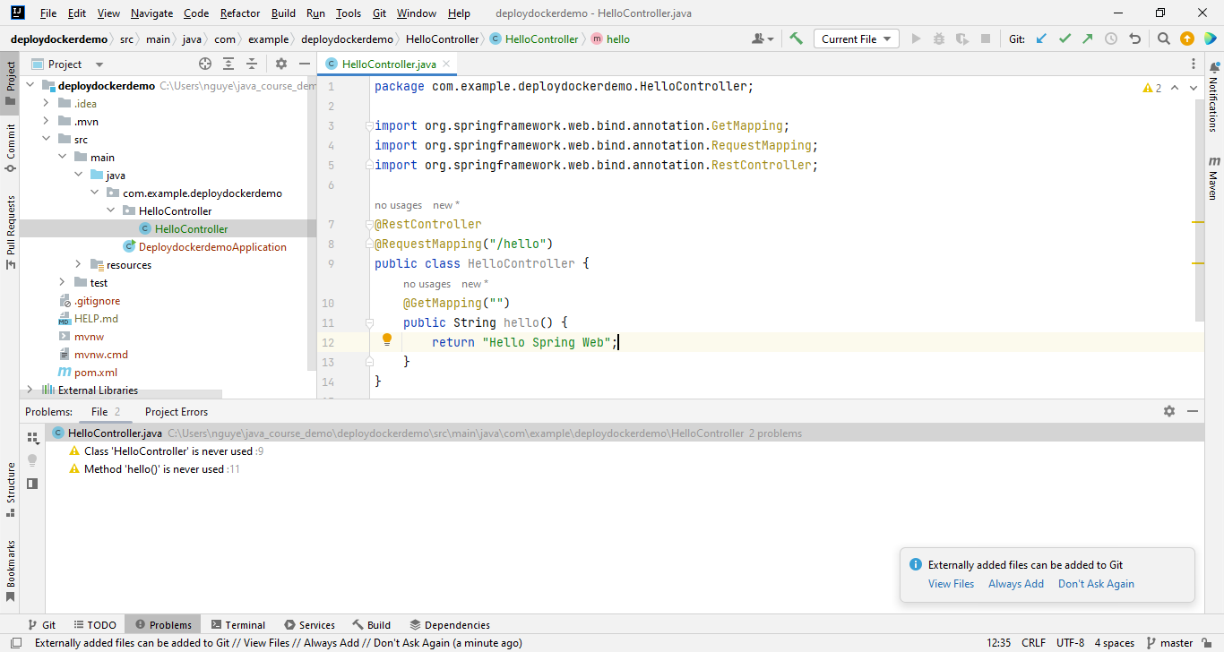

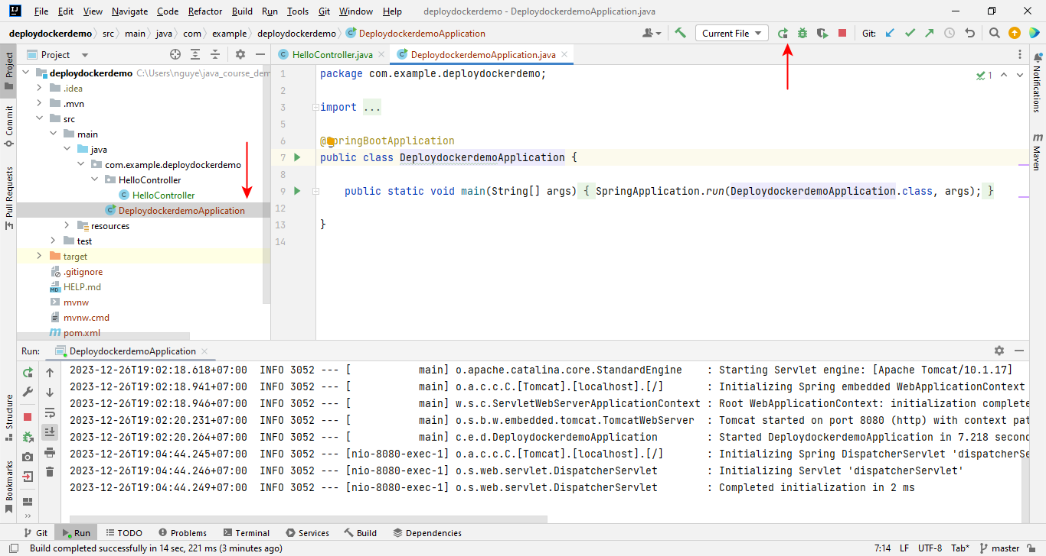

<http://localhost:8080/hello>

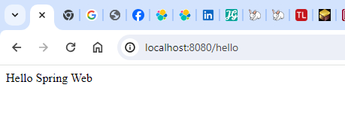

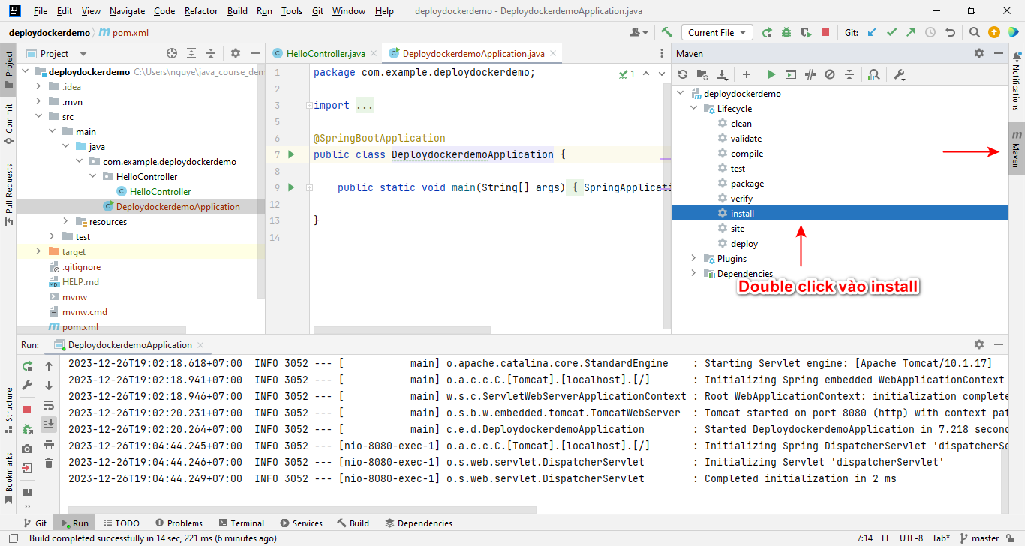

Muốn cung cấp CI/CD thì phải viết file kịch bản install Maven (search trên mạng)

clean: dùng để xóa cache của Maven

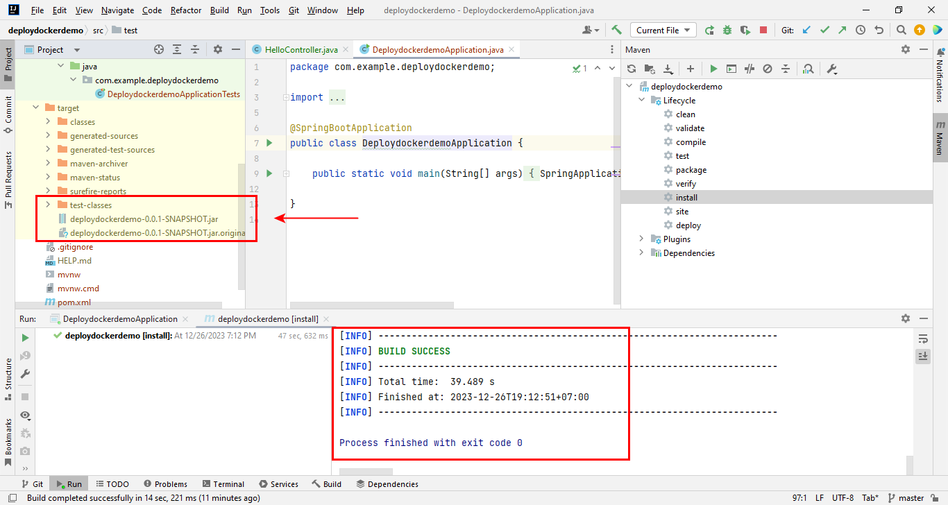

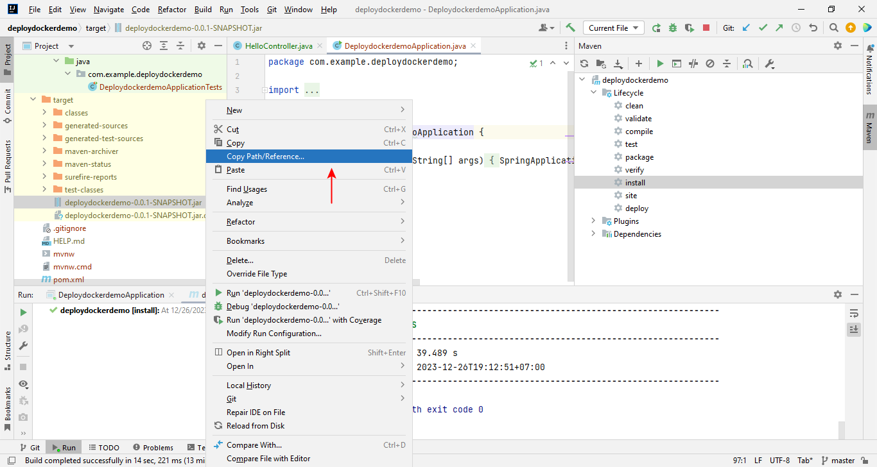

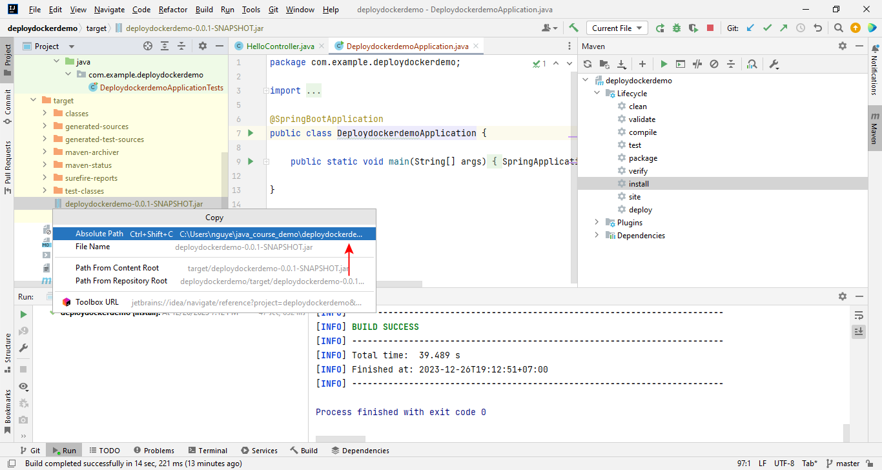

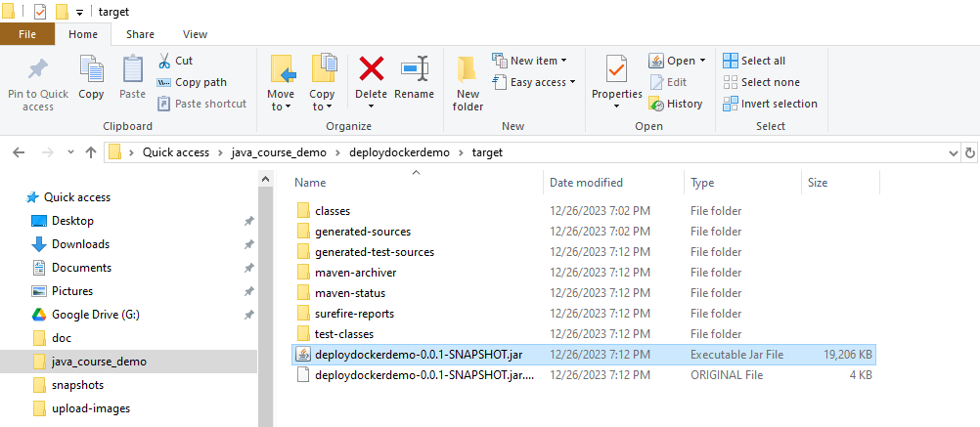

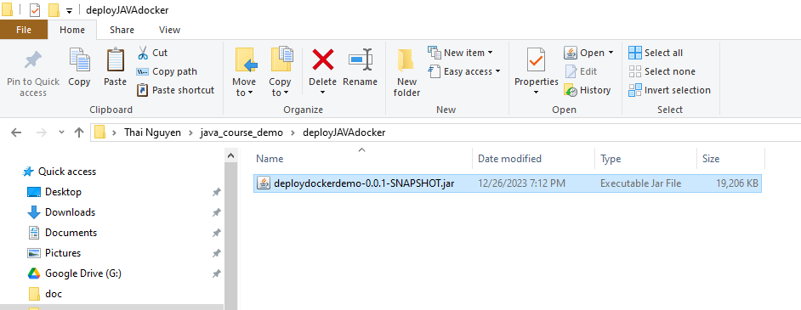

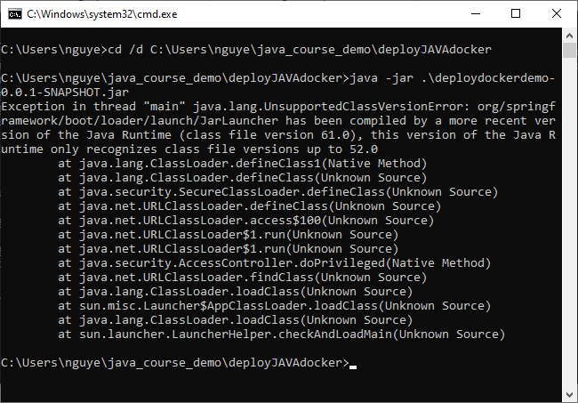

Create Dockerfile

# Use an official Java runtime with Java 17 as a parent image

FROM openjdk:17-alpine

# Set the working directory in the container

WORKDIR /usr/app

# Copy the JAR file into the container at /usr/app

COPY ./deploydockerdemo-0.0.1-SNAPSHOT.jar /usr/app

# Make port 8080 available to the world outside this container

EXPOSE 8080

# Run the JAR file

ENTRYPOINT ["java", "-jar", "deploydockerdemo-0.0.1-SNAPSHOT.jar"]

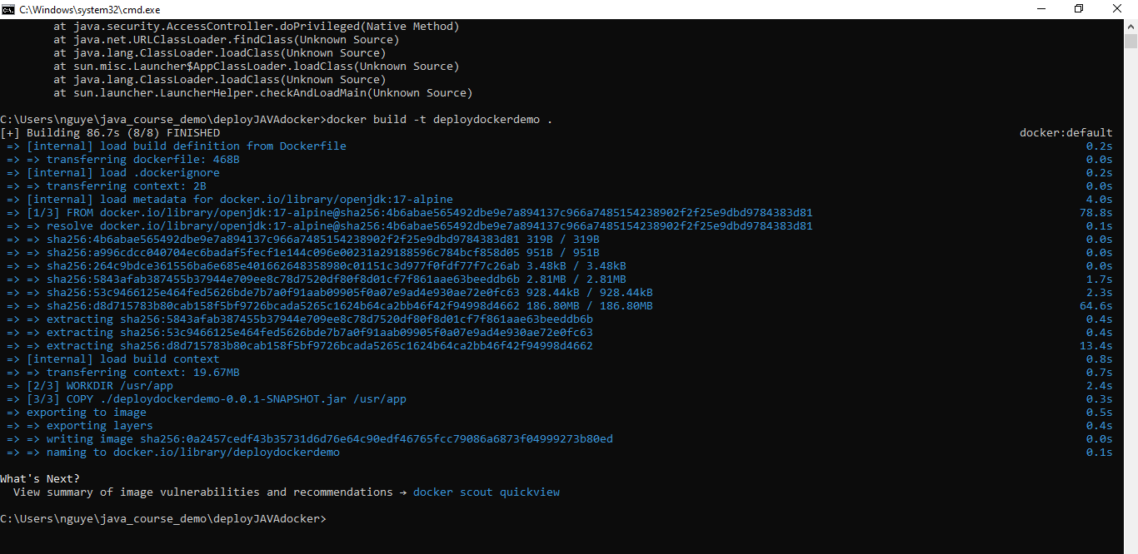’

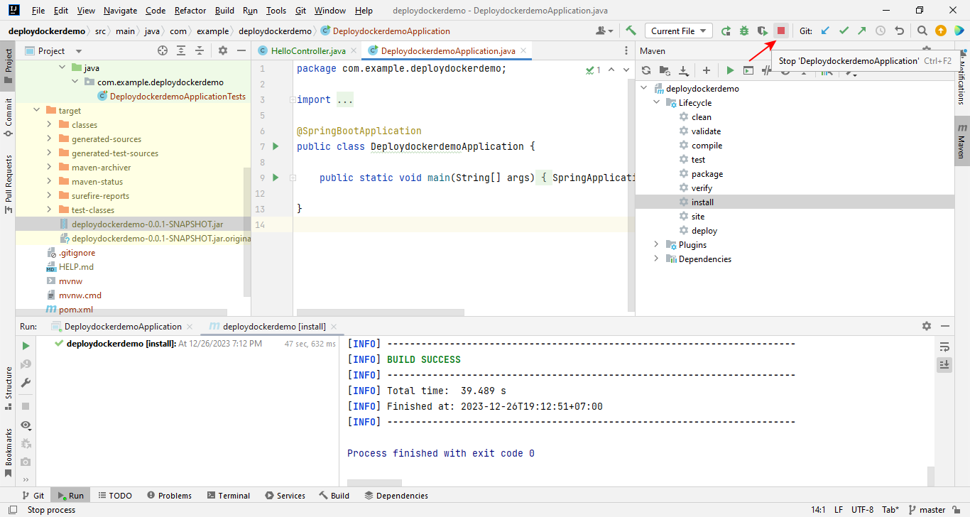

C:\Users\nguye\java_course_demo\deployJAVAdocker>docker run -p 8080:8080 deploydockerdemo

docker: Error response from daemon: Ports are not available: exposing port TCP 0.0.0.0:8080 -> 0.0.0.0:0: listen tcp 0.0.0.0:8080: bind: Only one usage of each socket address (protocol/network address/port) is normally permitted.

